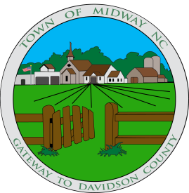

TOWN OF MIDWAY
PLANNING AND ZONING BOARD AGENDA
MEETING VIA ZOOM VIDEOCONFERENCE
TUESDAY, APRIL 28, 2020
426 GUMTREE ROAD
5:00 PM

CALL TO ORDER

- DETERMINATION OF QUORUM

- ADOPTION OF MINUTES

Regular Meeting – January 28, 2020

ADOPTION OF AGENDA

- PUBLIC COMMENT PERIOD

- REGULAR BUSINESS

Request for Variance - Core Commercial Overlay District – Lash Properties – 11173 Old US Hwy 52

ADJOURN

