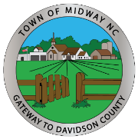
TOWN OF MIDWAY
TOWN COUNCIL
OCTOBER 19, 2020
Vision Session Town Hall 6:00 PM
426 Gumtree Road
Winston-Salem, NC 27107

- CALL TO ORDER

- ADOPT AGENDA

- VISION SESSION
- Updates of Vision Priorities from February 2020 Vision Session

- Discuss and Identify Vision Priorities

- Discuss Candidates for Planning and Zoning Board

- Make Appointments to Planning and Zoning Board
a. Regular Member Appointment
b. Alternate Member Appointment

- TOWN MANAGERS REPORTS

- Land Use Plan – Community Survey Results – For Information Only
- Elected Officials Ethics Training - Reminder

- ADJOURNMENT

